Activity 1.5 The Deep Dive

Introduction
How do professional design companies work through a design process? The video you are about to see chronicles the efforts of a world-renowned design firm, as they apply their process to the redesign of a common, everyday product.

One of the best-documented examples of the design process in action took place in Palo Alto, California, at an industrial design firm called IDEO. ABC News gave IDEO the challenge of redesigning the old and familiar shopping cart in just five days. Nightline chronicled the experience and aired the program on February 9, 1999.

This short documentary reinforces the idea that fantastic solutions can be produced under very difficult constraints when the designers have a commitment to the problem, a firm understanding of a design process, and a willingness to operate as a team.

In this activity you will watch the Deep Dive documentary and record information related to the design process used in the redesign of a shopping cart.

Procedure
In this activity you will watch a group of professionals work to solve a design problem in just five days. Answer the following questions as you watch The Deep Dive. A class discussion will take place following the broadcast.

- “From the buildings in which we live and work, to the cars we drive, or the knives and forks with which we eat, everything we use was designed to create some sort of marriage between _________________ and _________________.”

- The folks at IDEO state that they are not experts in any given area. But they do claim to be experts on the ____________________, which they apply to the innovation of consumer products.

- After the team of designers is brought together, introduced to the problem, and informed they have five days to “pull it off,” what phase of the design process do they immediately engage in?

- Give two examples of what the team members did during this phase.
  - _____________________________________________________
  - _____________________________________________________

- List five rules-of-thumb that IDEO employees follow when they share ideas during the brainstorming phase:
  - _____________________________________________________
  - _____________________________________________________
  - _____________________________________________________
  - _____________________________________________________
  - _____________________________________________________

- Why should wild (and sometimes crazy) ideas be entertained during the brainstorming phase?

- After the brainstorming phase was over, the team narrowed down the hundreds of ideas by _____________ for those ideas that were not only “cool” but also _________________ in a short period of time. Which phase of the design process includes brainstorming and narrowing ideas?

- IDEO believes that the ideas and efforts of a ______________ will always be more successful than the planning of a lone genius.

- Once the ideas were narrowed down and divided into categories, the group was split into four smaller teams. For which phase(s) of the design process was each of these groups responsible?

- The leaders at IDEO believe that ________________ behavior and a ______________ environment are two important reasons why their employees are able to think quickly and creatively to produce innovative results.

- Sometimes, people come up with great solutions that work by trying their ideas first and asking for _________________ later.

- Design is often a process of going too far and having to take a few steps back. What phase(s) of the design process would the critique of the four mock-ups come under?

- Upon critique of the four teams’ models, it was obvious that none of the teams had developed an optimum solution. However, the people at IDEO believe that it is important to _____________ often in order to _____________ sooner.

- What percentage of the entire week’s time did it take to fabricate the final prototype?

- Instead of showering his design team with a tremendous amount of praise, what did the boss require his employees to do with their new design?

- Of all the things that we are surrounded by every day, what has not been placed through the design process?

Conclusion
- What was the most impressive part of the team’s effort?

- What advantages are there to having a design team with members that have non-engineering backgrounds?

- There was a point in the process where a self-appointed group of adults stepped up, stopped the ideas, and redirected the group to break up into teams. Why was this done?

- At the end of the video, Dave Kelly states, “Look around. The only things that are not designed are the things we find in nature.” Can you think of anything that would contradict this statement?

- Consider the various versions of a design process (below) that were introduced in the Design Process presentation that you viewed. How are the processes similar? How are they different?
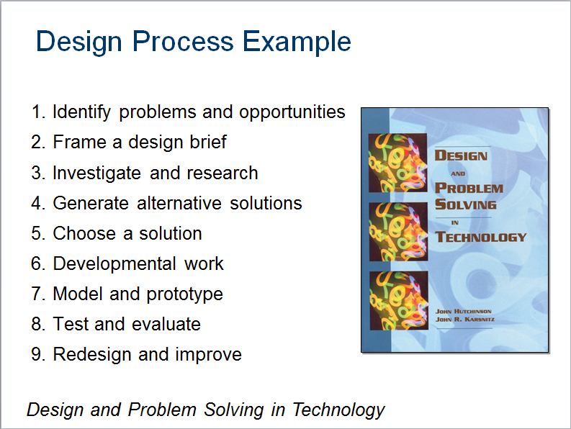 | 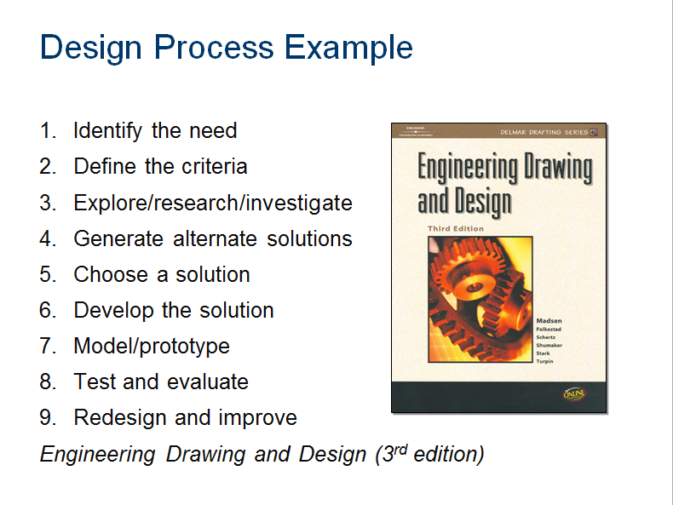
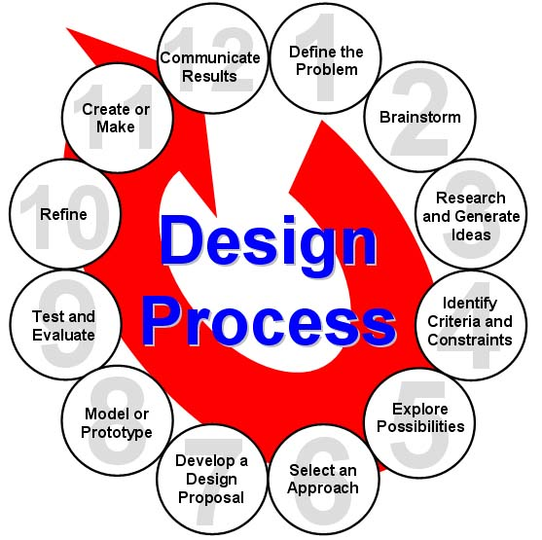  ITEA Standards for Technology Literacy | 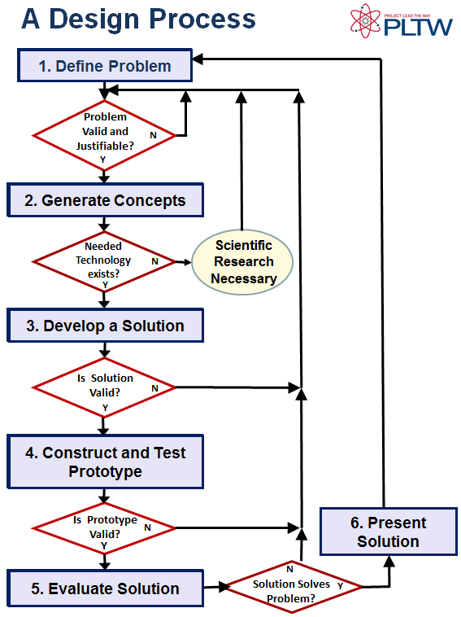  Design Process used in IED

- Do you think the tasks completed by the design team during the design challenge or the final solutions have changed if the team had followed a different version of a design process? Explain.

